**SOFTWARE REQUIREMENTS SPECIFICATION**

**AND**

**SOFTWARE DESIGN SPECIFICATION**

**REPORT**



**SCS 2102 Group : CS-21**

**TABLE OF CONTENTS**

**Group Details 03**

**Project Supervisor, Mentor and Client Details 03**

1. **INTRODUCTION 04**

1.1 Purpose 04

1.2 Acronyms and Abbreviations 04

1.3 Domain Description 05

1.4 Current System 05

1.5 Limitations of the Current System 06

1.6 Proposed Solution 07

1.7 Goals and Objectives 09

1.8 In-Scope 09

1.9 Out-of-Scope 09

1.10 Assumptions 09

1.11 Constraints and Limitations 10

1.12 Work Distribution Among the Group Members and Individual Contribution 10

2. **FEASIBILITY STUDY 11**

2.1 Economic Feasibility 11

2.2 Operational Feasibility 11

2.3 Ethical Feasibility 11

2.4 Technical Feasibility 11

2.5 Risk Feasibility 12

2.6 Resource Feasibility 12

2.7 Schedule Feasibility 12

3. **REQUIREMENTS 14**

3.1 Stakeholders 14

3.1.1 Owner/Administrator 14

3.1.2 Receptionist 14

3.1.3 Registered Customer 14

3.1.4 Unregistered Customer 15

3.2 Use Cases and Use Case Diagrams 15

3.3 Functional Requirements 20

3.3.1 Use Case Narratives 20

3.4 Non-Functional Requirements 27

4. **PROPOSED SYSTEM ARCHITECTURE 28**

4.1 High Level Architecture (Three-Tier Architecture) 28

4.2 Layers and their Responsibilities 29

4.2.1 Presentation Tier 29

4.2.2 Application Tier 29

4.2.3 Data Tier 30

4.3 Component Interactions 31

5. **SYSTEM DESIGN 32**

5.1 Class Diagram 32

5.2 Sequence Diagrams 33

5.3 Activity Diagrams 40

5.4 Database Design 44

5.4.1 Entity Relationship Diagram (ERD) 44

6. **INTERFACES 45**

6.1 User Interface Flow Diagrams 45

6.2 User Interface Mockups 46

**Group Details**

|  |  |  |  |  |
| --- | --- | --- | --- | --- |
| **No.** | **Full Name** | **Registration No.** | **Index No.** | **Signature** |
| 1 | M.A.C. Silva | 2016/CS/137 | 16001372 |  |
| 2 | W.R. Chinthaka | 2016/CS/021 | 16000218 |  |
| 3 | P. Santhiran | 2016/CS/126 | 16001265 |  |
| 4 | K. Jeyatharan | 2016/CS/065 | 16000651 |  |

**Project Supervisor, Mentor and Client Details**

* **Project Supervisor**

Mr. Rangana Jayashanka

* **Project Mentor:**

Ms. Waruni Kandamby

* **Project Client:**

N Studio Zumba

No. 176D, Negombo Road,

Rilaulla,

Kandana.

Sri Lanka.

Owned by Ms. Nilrukshi De Silva

1. **INTRODUCTION**

**1.1** **Purpose**

This documentation provides a detailed description on the requirements of **N Studio Zumba Fitness** which is a women’s only Zumba Fitness Center. Firstly, it’ll take a look at the current system and limitations associated with it. Then the proposed system with the scope, goals and objectives of developing along with its limitations and constraints are given. Furthermore system’s feasibility, requirements, architecture, design and interfaces of the proposed system are discussed. In general this document will layout the system’s analysed requirements and the proposed system’s design will be described with the aid of diagrams.

**1.2**  **Acronyms and Abbreviations**

* **HTML - Hypertext Markup Language**,standard markup language for creating web pages.
* **CSS - Cascading Style Sheets**, simple design language intended to simplify the process of making web pages presentable.
* **SQL - Structured Query Language**, standard language for storing, manipulating and retrieving data from databases.
* **MySQL -** MySQL is an open source RDBMS (Relational Database Management System) that uses SQL (Structured Query Language).
* **PHP - Hypertext Preprocessor**, server scripting language, and a powerful tool for making dynamic and interactive web pages.
* **jQuery -** jQuery is an open source JavaScript library that simplifies the process of adding advanced functionality to web projects.
* **ERD - Entity Relationship Diagram**
* **IDE - Integrated Development Environment**, software suite that consolidates the basic tools developers need to write and test software.

**1.3 Domain Description**

N Studio Zumba Fitness is a women’s only fitness center which aids customers to meet their fitness goals while setting the right motivation to strive for excellence. The fitness center offers zumba classes as well as workout sessions which are distributed in the form of packages, 5 days per week, 3 days per week, daily and weekend.

Qualified and experienced zumba instructor(administrator) aids customers to meet their health and fitness objectives along with workout goals.

**1.4 Current System**

Current System is based on manual maintenance of all records relevant to the customers, services and payments which is highly inefficient. In order to join the class, the customer has to visit the class and see available days and packages or call the fitness center. Also the scheduling system which assigns customers to relevant zumba sessions is not well maintained, leading to exceed client limit for some sessions. Payment gathering from customers is not done in an efficient manner and hence, hard to determine those who have not made the payment in due time.

The proposed web application will automate all manual processes together with few more functionalities which will help to gain more customer attraction and ease the effort of maintaining records.

**Stakeholders**

Stakeholders of the current system are:

* Administrator
* Receptionist
* Customer
  + Registered Customer
  + Unregistered Customer

Out of the mentioned stakeholders, Administrator and Receptionist are primary actors while Customers are secondary actors.

**1.5 Limitations of the Current System**

Some of the limitations that were noticed in the current system are given below.

**Inefficient scheduling system**

No proper way to manage the number of customers coming for a given class. In addition to that customers have no efficient way of cancelling or rescheduling a class.

If client limit of a particular slot is exceeded, customers have to wait till their turn. This may reduce the quality of service and ultimately reduce the customer base of the fitness center.

Also the admin has a hard time tracking the number of classes covered by a particular customer. This is a crucial limitation of the current system.

**Inefficient payment handling**

Payment handling is not done in a very efficient manner in the current system. Since all payment are gathered by the receptionist and their details are maintained manually, processing these information to manage those who have not made payments in due time can be tough. This is a major limitation in the system.

**Limitations at registration**

In the current system the customers have to call or visit the fitness center in order to register. Once a customer registers all personal details, selected package details, booked class details and payment details have to be managed manually. This is a common limitation found in many systems which are not automated.

**Inefficient maintenance of customer details**

Maintenance of customer details manually is very time consuming. Currently this limitation can be seen in the system. Even to pass a class cancellation message can be hard, as every customer’s contact details have to be accessed manually. This will lead to the increment of workload.

**Inefficient maintenance of employee details**

Receptionist is the only employee in the current system, but managing the relevant details and salary payments can be identified as a limitation.

**Limitations of report generation**

Since a manual method is followed in the current system, report generation for managerial decisions can be time consuming and therefore can be identified as a limitation.

**Summary**

N Studio Zumba Fitness Center currently manages all relevant details manually. With the technological advancements in the current society, all this could easily be managed in a more efficient manner. Thus a solution to these limitations are provided through a web based system for N Studio Zumba Fitness, which will manage all the functionalities required by the client. Also through this web application, customer base can be easily expanded.

**1.6 Proposed Solution**

As a solution to the above discussed limitations in the current system, a web application is introduced for N Studio Zumba Fitness. The proposed solution will provide the following functionalities,

* Customer management system
* Online scheduling system
* Payment management system
* Notification system
  + General notifications
  + Health tips
  + Medical advices
* Report generation system
* Easy system access from anywhere at anytime

The proposed solution mainly provide the functionality of managing the scheduling process and payment process. In addition to these it allows to manage customer and receptionist details efficiently while providing reports for higher managerial processes. Through this web based solution customers can access the system from anywhere at anytime and the packages available in the fitness center can be easily viewed.

The customers of the fitness center are of 2 categories, namely registered and unregistered. Unregistered customers can only access the static web pages on the web application.

Registered customers get many more privileges in addition to accessing the static pages. When registering, customer has to provide basic details along with the package(5 days per week, 3 days per week, daily or weekend) and prefered class schedule(time slots). If this slot is not available customer is notified. Once the registration request is accepted by the admin of the system, a confirmation message is sent to the customer. Thereafter the system can be accessed by providing the username and password. Registration fee needs to be settled once the request is accepted. By managing the registration process in this manner, all details can be stored and managed efficiently.

The selected package can be changed and the class schedule time slots can be cancelled or rescheduled. Administrator has the ability to hold user accounts(deactivate) which are inactive or even delete them.

Receptionist’s account is created by the admin. But these details can be managed and altered by both the admin and receptionist.

Payments can be made through the online payment facility provided or through the cash payment to receptionist. If the payments for the classes are not made in due time, system automatically sends an alert to customers asking to make the due payment. Once a payment is made, it cannot be claimed again under any circumstances, but the customers have the ability to reschedule the classes and cover the required number of classes within the month. Through this functionality the payments can be managed efficiently.

Monthly salary payment for the receptionist is authorized by the admin, and settled through the system at the click of a button.

The admin and the receptionist have the power to view the customer list in the event calendar and see the customers attending a particular zumba session.

In case of general notifications like class cancellations, offers provided for payment discounts, additional zumba sessions provided can be notified to all customers at once. These will be sent to the website dashboard and also to registered customers.

Health tips are sent to all registered customers by the zumba instructor. For customers with medical issues who need special attention and guidance, admin reviews their details through the system and provide the necessary medical advice in the form of a message.

For a given zumba class session, receptionist marks the attendance of the customers. Also for every 2 weeks receptionist enters the weight updates of each customer. System can generate reports on weight, and reports on attendance. Administrator can view these reports, while customers can only view reports which belong to them.

Customers can send complaints and suggestions to the admin through the system. This functionality will help the owner to maintain the company standards by taking into consideration the customer requests,feedbacks and criticisms.

These mentioned functionalities will minimize the workload of the system users.

**1.7 Goals and Objectives**

**Goal**

Creating a web based system for our client in order to maintain good customer relationships while aiding them to meet their fitness goals.

**Objectives**

* Reengineering the business process using technological solutions by providing a web based platform.
* Ensure customer satisfaction.
* Gaining competitive advantage.
* Ease the payment gathering from customers.
* Handling the scheduling system in an efficient manner so as to decrease time wastage.
* Automate the manual system maintained for the customer progress report on weights.

**1.8 In-Scope**

The below given functionalities are intended to be provided through the web application.

* Registration management
* Scheduling management
* Payment management
* Notification management
* Report generation on attendance and weights

**1.9 Out-of-Scope**

The proposed system will not be flexible for system advancements due to future branches. Because the web application is based only around the current branch.

**1.10 Assumptions**

* Payments made cannot be reclaimed according the the business rule of the company. If the required number of classes are not covered for the paid amount, customer has the ability to reschedule more classes to cover the classes in the course of that month. This is because a payment is made prior to the due month and is valid only for that month.
* In the case of a customer taking few months off, administrator can deactivate the account so that the payment alert sent is avoided.
* Customers who do not have access to the web based system are maintained through the receptionist. This includes creating accounts, updating account and making payments.

**1.11 Constraints and Limitations**

* Interacting with customers who cannot access the internet

Customers without internet access has no way of interacting with the web application. No notifications are received by them. This is a limitation of the system which cannot be eliminated.

* Time management

With the high amount of functionalities required by the client, completing this web application within this time constraint is a challenging task.

**1.12 Work Distribution Among the Group Members and Individual Contribution**

|  |  |  |  |
| --- | --- | --- | --- |
| **No.** | **Full Name** | **Registration No.** | **Contribution** |
| 1 | M.A.C. Silva | 2016/CS/137 | Drew ER diagram, Designed High Level Architecture, Drew User Interface Flow Diagrams, Wrote about the Requirements |
| 2 | W.R. Chinthaka | 2016/CS/021 | Drew Class Diagram, Feasibility Study, Non Functional Requirements, Wrote about Proposed System Architecture |
| 3 | P. Santhiran | 2016/CS/126 | Drew Activity Diagrams, Drew Class Diagram, Designed Interface Mockups, Drew Sequence Diagrams |
| 4 | K. Jeyatharan | 2016/CS/065 | Drew Sequence Diagrams, Drew Activity Diagrams, Wrote about Domain Description ,Current System and its Limitations ,Proposed System |

**2. FEASIBILITY STUDY**

**2.1** **Economic Feasibility**

There will be no costs involved with the development of the web application since it is done free of charge. However the cost of deployment of the web application is covered by the client. Therefore this web application is affordable.

With the manual system, passing general notifications such as class cancellations, extra zumba sessions, etc can be very costly to the client due to calling costs. With the web application this is handled in an efficient and economically feasible manner.

There will be no additional costs for the technologies used for the development process, as free technologies are used.

**2.2** **Operational Feasibility**

Four main users identified in our system are administrator, receptionist, registered and unregistered customers. Both registered and unregistered customers can easily interact with the system. They only need an internet connection and an accessible device along with some basic knowledge on browsing the web. Administrator and receptionist of the fitness center already have some IT knowledge, therefore can interact with the system. There is no need to train the users. This concludes that our system is operationally feasible.

**2.3** **Ethical Feasibility**

Personal details of users are maintained in a secure and confidential manner. Attention given to each customer with regard to their medical issues are maintained in a private and confidential manner. Our system guarantees that customers can communicate with the owner confidentially.

Legal issues regarding the softwares will not emerge as free and open source softwares are used for development. Hence our system is ethically feasible.

**2.4** **Technical Feasibility**

We are using modern and popular technologies to develop our web application. Our team has substantial knowledge on the technologies used to build the system.

HTML, CSS, JavaScript, jQuery and Bootstrap will be used for the front-end development. For the back-end development, we are using PHP and MySQL. The database management system( DBMS), MySQL which is a relational database is used.

PhpStorm is used as the IDE ( Integrated Development Environment ). PhpStorm provides an editor for PHP, HTML and JavaScript with on-the-fly code analysis, error prevention and automated refactorings for PHP and JavaScript code.

We hope to use GitHub and git for version control and collaboration of our project. It lets our team to share the project among the members, thus making the version control easy and efficient. For the web application testing purpose, we hope to use Selenium. Trello will be used as the project management tool, which is regarded as one of the best web-based project management tools.

**2.5** **Risk Feasibility**

Risk of every team member not being able to complete the assigned tasks, due to unavoidable reasons within given time frame exists. In order to get over this risk the others should increase the work put in to the development of the project.

Strikes and other issues faced may affect the scheduled plan to complete this project. This risk needs to be managed by collaborating with the team members constantly.

**2.6** **Resource Feasibility**

An academic year is allocated for the project completion. This resource is managed in an efficient manner by allocating time periods for all tasks.

With the project supervisor and mentor assigned to our team, necessary advice and guidance is gathered.

Resources and technologies used for the development are free and open source. Set of skills possessed by our team members have a wide variety.

**2.7** **Schedule Feasibility**

The software development methodology that we have chosen is **Incremental Methodology**. We have distributed the tasks throughout the academic year as shown below in the gantt chart. This depicts the schedule feasibility.

The proposed time schedule includes 2 increments which will be handed over to the client.

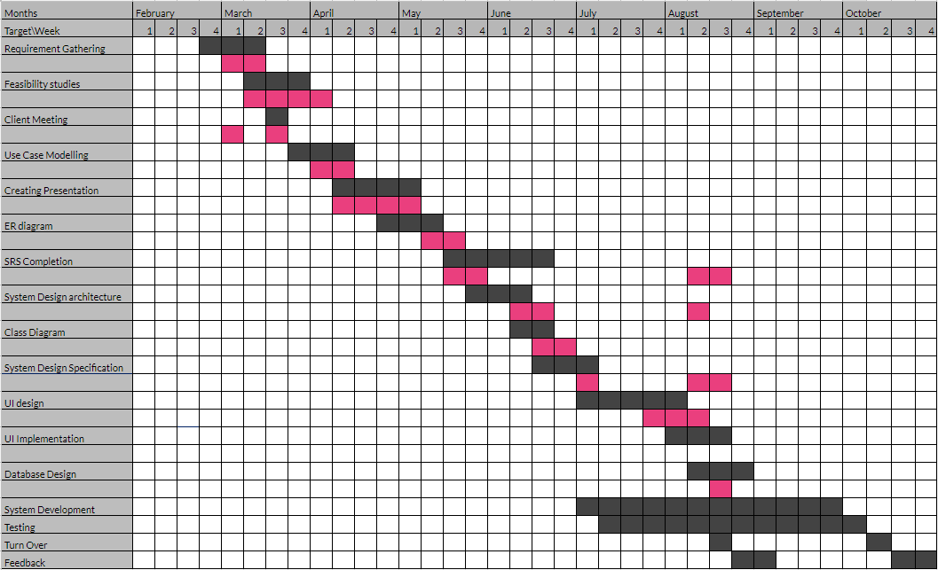

**3. REQUIREMENTS**

**3.1** **Stakeholders**

A stakeholder is a party that has an interest in a company and can either affect or be affected by the system. The stakeholders identified in the fitness center are Owner, Receptionist, Registered Customer and Unregistered Customer.

**3.1.1 Owner/Administrator**

Admin is responsible for appointing a receptionist. Admin can manage receptionist and registered customer details, generate weight and attendance reports.

Admin is responsible for confirmation of user accounts. Also has the power to hold user accounts due to customer’s unavoidable reasons ( so that monthly payment is avoided and automatic payment delay alerts are avoided ) or even delete the user accounts. Admin has to authorize salary payments for the receptionist.

Admin can view schedule details, can create/delete classes and can extend client limits for classes. In addition, admin handles the notification system. This may be sending health tips to customers, sending general notifications to the website and customers, sending medical advice to those needed.

**3.1.2 Receptionist**

Receptionist can manage receptionist’s details, create customer account by selecting the class package and preferred class schedule, manage customer accounts, maintain customer attendance, collecting payments from those who follow the cash payment method and updating the system and enter weight updates for customers.

**3.1.3 Registered Customer**

Registered customers can update their accounts, make payments through online payment system, send complaints and suggestions to the owner directly and receive notifications about health tips and advice for any medical issues. Registered customers can reserve a particular time slot for zumba sessions via online scheduling system. This functionality gives the ability to cancel or reschedule a reservation. Also customers will receive alerts in case of payment delays. Additionally they can view progress reports on weights.

**3.1.4 Unregistered Customer**

Unregistered customers can register to the zumba fitness center, but admin has the power to accept or reject the registration request. Additionally they have access to the static web pages such as about us, gallery, schedule, class packages,success stories,etc. of the web application.

**3.2** **Use Cases and Use Case Diagrams**

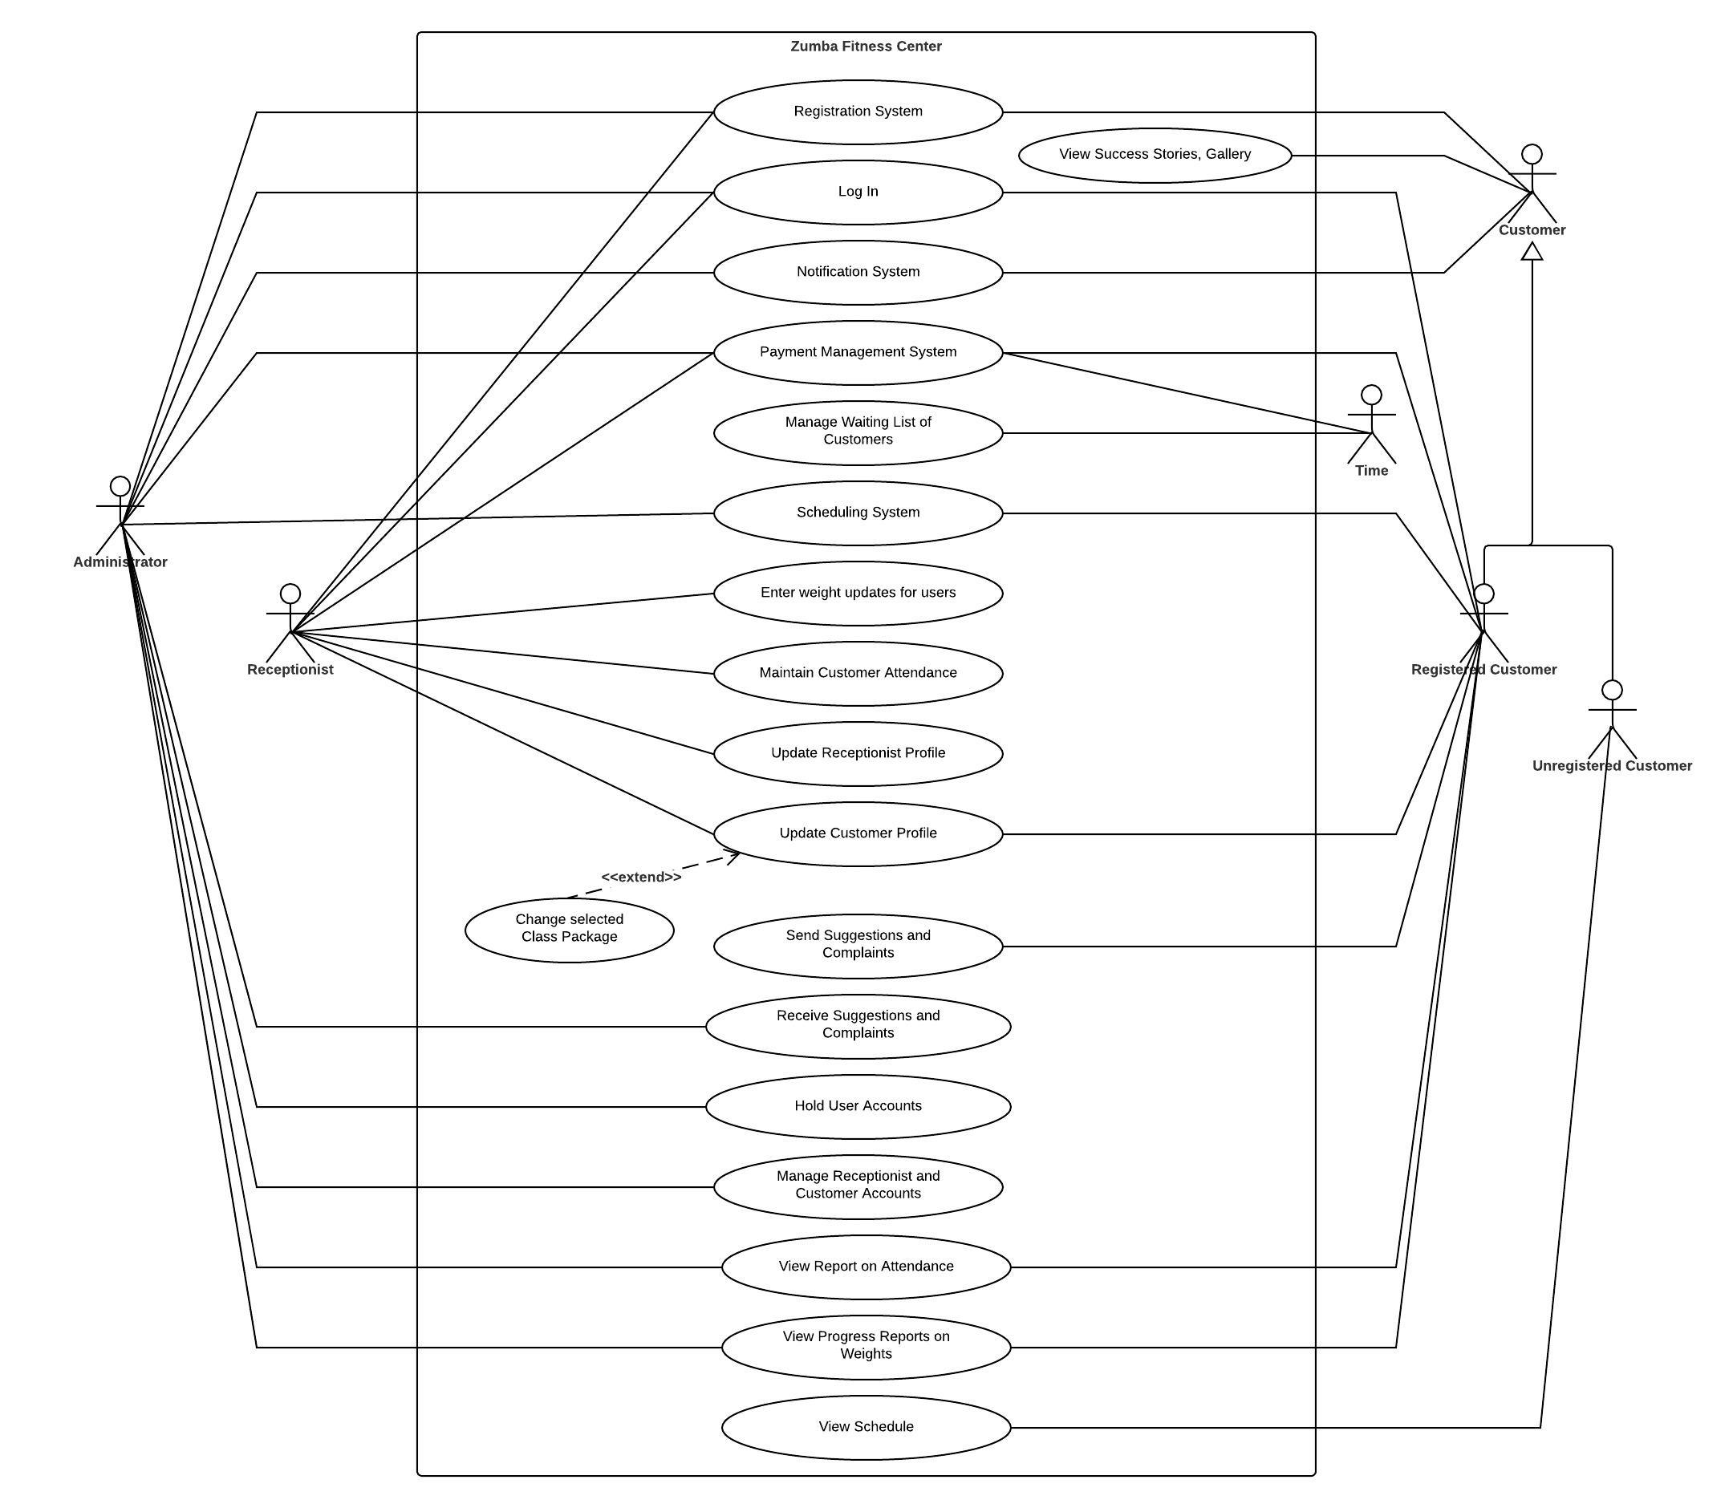

* **Unregistered Customer**

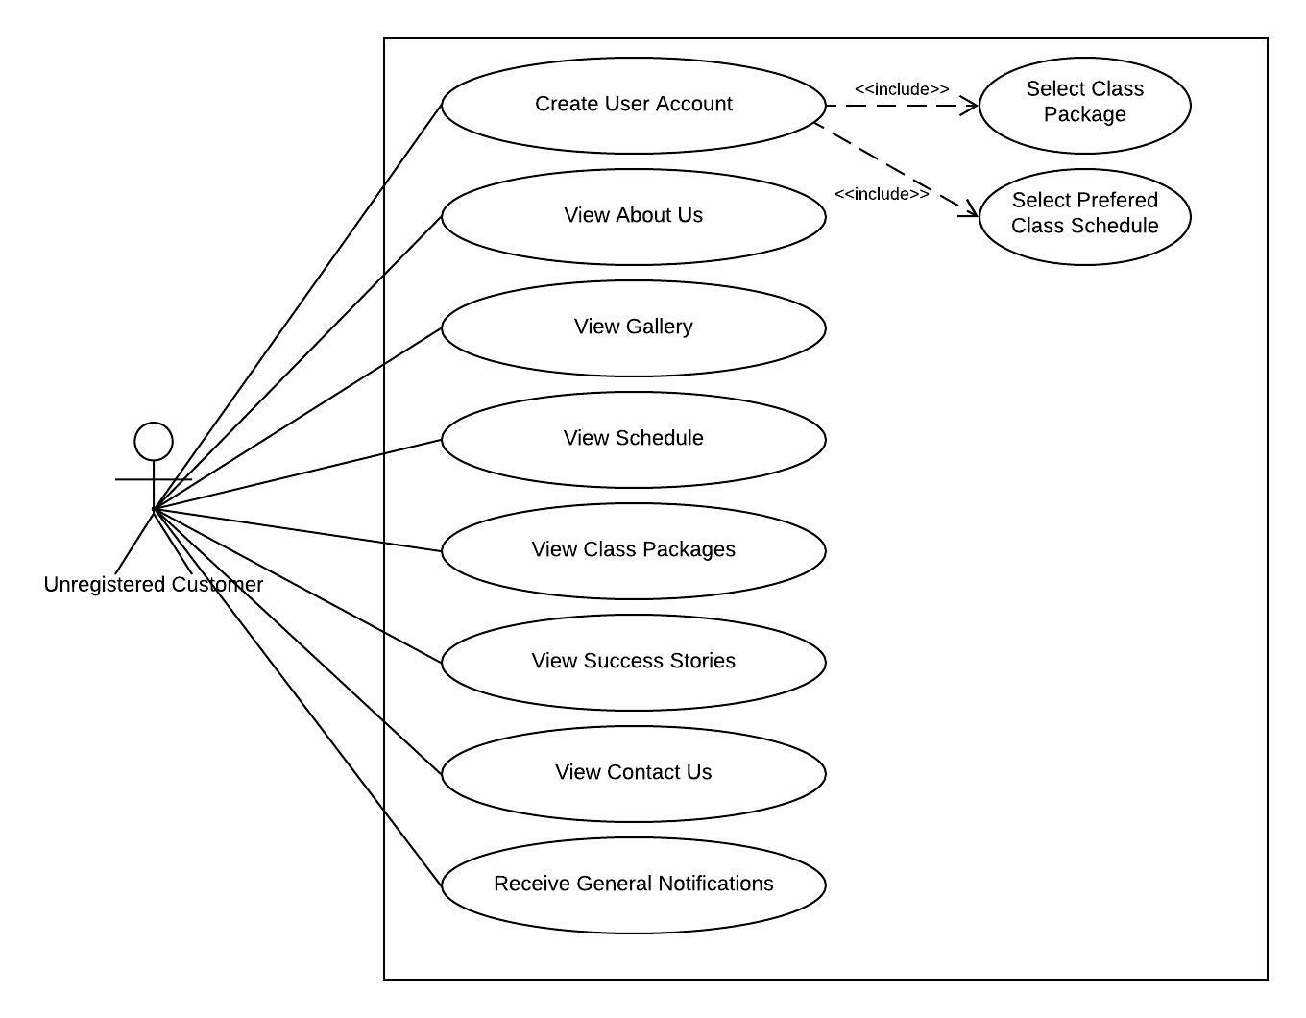

* **Registered Customer**

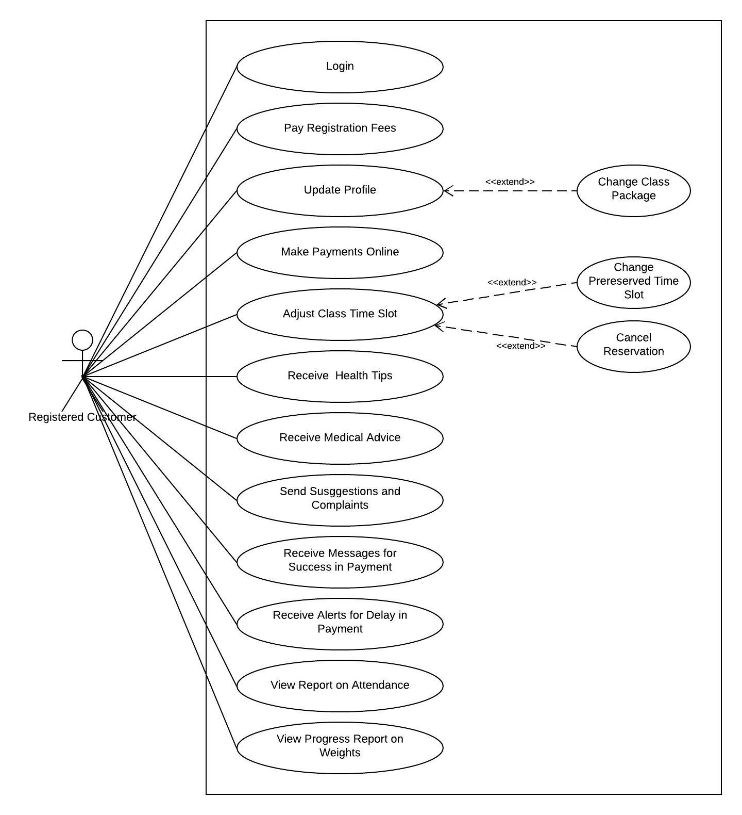

* **Receptionist**

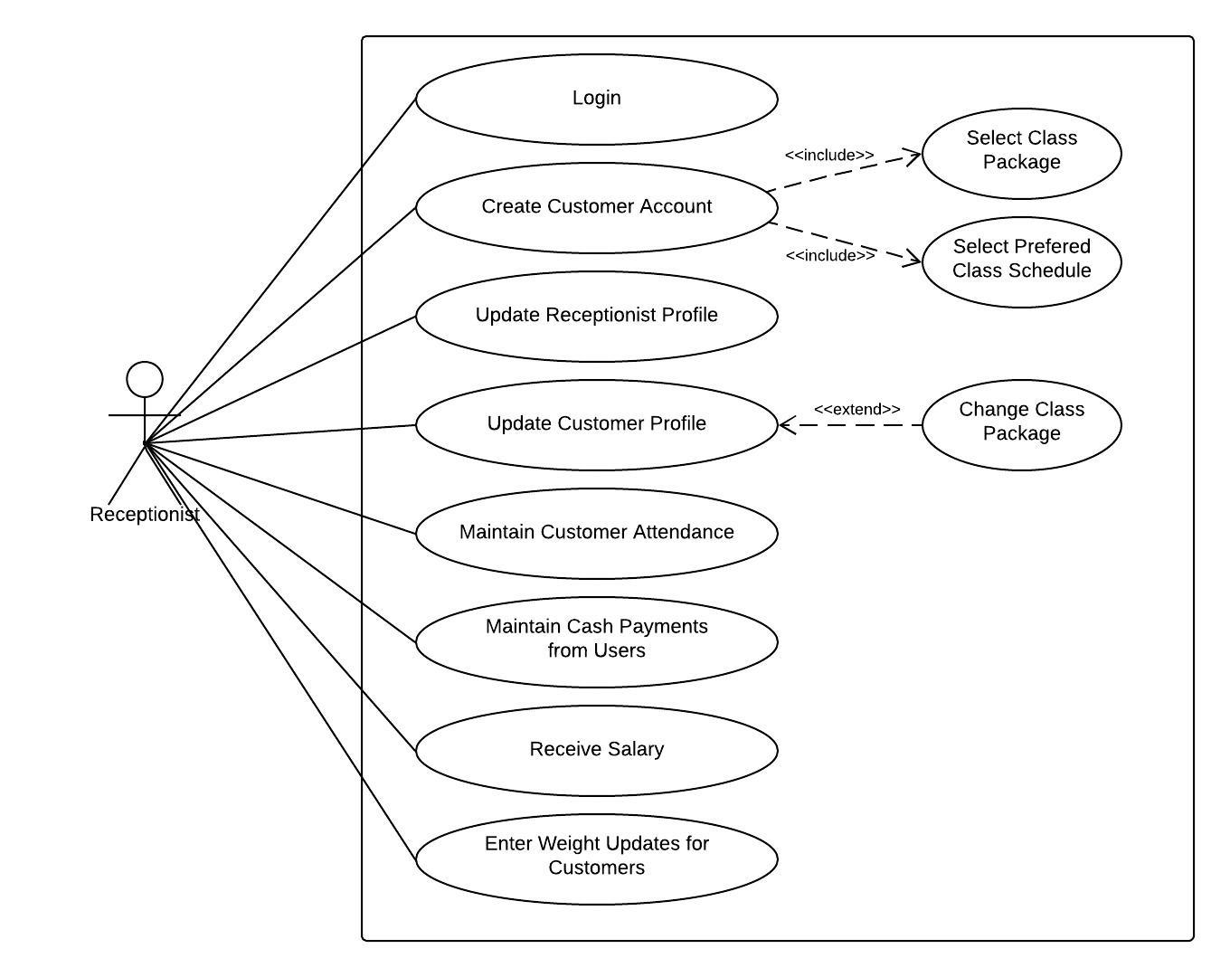

* **Owner / Administrator**

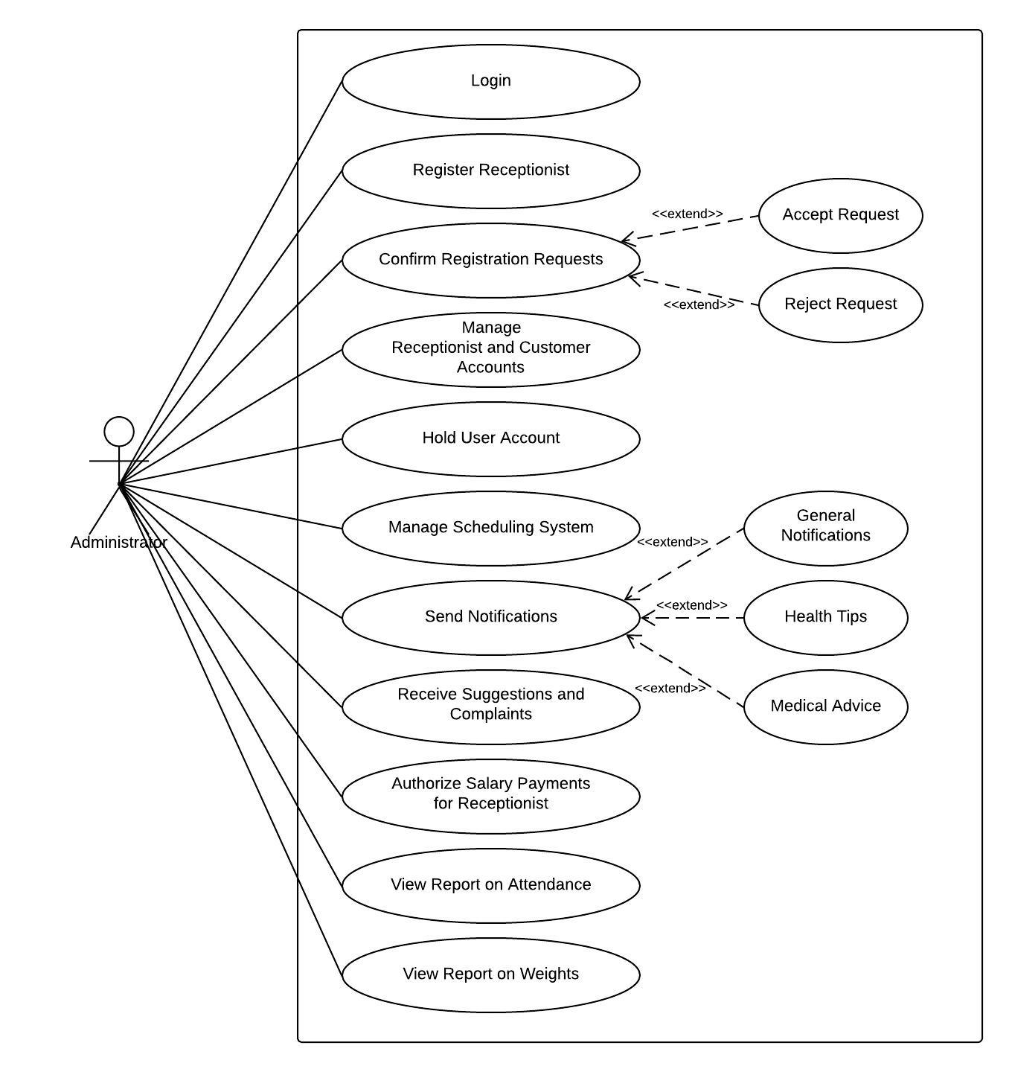

**3.3** **Functional Requirements**

1. Login
2. Send Register Request
3. Confirm Register Request
4. Online Payment of Registration Fees
5. Collecting Cash Payment of Registration Fees
6. Select Class Package and Class Schedule
7. Make Payments Online
8. Collecting Cash Payments
9. Alerts for delay in payment
10. Adjust Class Timeslot
11. Manage Receptionist
12. Manage Customers
13. Manage Scheduling System
14. Send Suggestions and Complaints
15. Send Notifications
16. Maintain Attendance
17. Enter Weight Updates
18. Generate and View Reports

**3.3.1 Use Case Narratives**

|  |  |
| --- | --- |
| Use case 01 | Login |
| Primary actor | Admin, Receptionist, Registered Customer |
| Preconditions | Internet connection |
| Main Flow | 1. Go to the website 2. Go to Login 3. Fill username and password 4. Click Login Button |
| Alternative Flow | If username and password entered is not valid, display error message |
| Postconditions | User is directed to the homepage of N Studio Zumba Fitness according to the user type |

|  |  |
| --- | --- |
| Use case 02 | Send Register Request |
| Primary actor | Unregistered Customer |
| Preconditions | Internet connection |
| Main Flow | 1. Go to the web site 2. Go to the sign up 3. Fill the details 4. Click Submit button to send a registration request to admin |
| Alternative Flow | Validate the details which were entered  Allow customer to re-enter data if any error detected |
| Postconditions | Request sent to admin |

|  |  |
| --- | --- |
| Use case 03 | Confirm Register Request |
| Primary actor | Admin |
| Preconditions | Logged into the system, Received registration requests |
| Main Flow | 1. Select Register Requests 2. Check details of each request ( gender validity, medical status, age ) 3. Accept / Reject request |
| Alternative Flow | If multiple requests are sent, reject  If not female, reject  If medical condition too critical, reject |
| Postconditions | Send confirmation email to customer |

|  |  |
| --- | --- |
| Use case 04 | Online Payment of Registration Fees |
| Primary actor | Registered Customer |
| Preconditions | Received the confirmation email after admin approval, Clicked the link |
| Main Flow | 1. Enter details to make the payment 2. Click Pay button |
| Alternative Flow | Entered credentials are not valid and the payment is rejected |
| Postconditions | Send success message  Redirected to the homepage |

|  |  |
| --- | --- |
| Use case 05 | Collecting Cash Payment of Registration Fees |
| Primary actor | Receptionist |
| Preconditions | Relevant customer received the confirmation email after admin approval, Receptionist logged into the system |
| Main Flow | 1. Go to payments 2. Select registration fees option 3. Select the relevant customer 4. Update payment status after accepting the payment |
| Alternative Flow | None |
| Postconditions | Send success message |

|  |  |
| --- | --- |
| Use case 06 | Select Class Package and Class Schedule |
| Primary actor | Registered Customer, Receptionist |
| Preconditions | Logged into the system |
| Main Flow | 1. Select class package 2. Select a preferred class schedule according to the package selected |
| Alternative Flow | If selected schedule already filled, notify the customer and waitlist them. |
| Postconditions | None |

|  |  |
| --- | --- |
| Use case 07 | Make Payments Online |
| Primary actor | Registered Customer |
| Preconditions | Logged into the system, Availability of a debit card or a credit card |
| Main Flow | 1. Go to the Payments 2. Fill the details 3. Confirm the payment ( Amount is automatically calculated based on the selected package ) |
| Alternative Flow | If the entered credentials are not valid, display an error message  Allow user to re-enter data |
| Postconditions | Send message for success in payment |

|  |  |
| --- | --- |
| Use case 08 | Collecting Cash Payments |
| Primary actor | Receptionist |
| Preconditions | Logged into the system |
| Main Flow | 1. Go to the Payments 2. Select monthly payment option 3. Select the relevant customer 4. Update payment status after accepting the payment |
| Alternative Flow | None |
| Postconditions | Send message for success in payment |

|  |  |
| --- | --- |
| Use case 09 | Alerts for delay in payment |
| Primary actor | Time |
| Preconditions | None |
| Main Flow | 1. Check for customers who have registered for any package 2. Check if the payment is settled for the current month 3. If payment not settled, send a SMS as a reminder to make the payment |
| Alternative Flow | None |
| Postconditions | None |

|  |  |
| --- | --- |
| Use case 10 | Adjust Class Timeslot |
| Primary actor | Registered Customer |
| Preconditions | Logged into the system |
| Main Flow | 1. Go to the Schedule Page 2. Adjust pre reserved time slot ( for current week ), but can only select upto the maximum limit provided by the selected class package    1. Reschedule time slot    2. Remove time slot |
| Alternative Flow | If class slot removed from schedule, check the waitlisted customers and notify them regarding the availability |
| Postconditions | None |

|  |  |
| --- | --- |
| Use case 11 | Manage Receptionist |
| Primary actor | Admin, Receptionist |
| Preconditions | Logged into the system |
| Main Flow | 1. Go to Manage Receptionist 2. Select option,    1. Add receptionist ( only admin )    2. View receptionist    3. Update receptionist    4. Delete receptionist ( only admin ) |
| Alternative Flow | None |
| Postconditions | None |

|  |  |
| --- | --- |
| Use case 12 | Manage Customers |
| Primary actor | Admin, Receptionist |
| Preconditions | Logged into the system |
| Main Flow | 1. Go to Manage Customers 2. Select option,    1. Add customer    2. View customer    3. Hold customer account (admin only)    4. Delete customer (admin only) |
| Alternative Flow | None |
| Postconditions | None |

|  |  |
| --- | --- |
| Use case 13 | Manage Scheduling System |
| Primary actor | Admin |
| Preconditions | Logged into the system |
| Main Flow | 1. Go to Manage Schedule 2. Select option,    1. Add zumba session    2. View/Extend the client limit on that time slot    3. View the number of enrolled customers for each time slot ( for current week )    4. Delete zumba session |
| Alternative Flow | None |
| Postconditions | None |

|  |  |
| --- | --- |
| Use case 14 | Send Suggestions and Complaints |
| Primary actor | Registered Customer |
| Preconditions | None |
| Main Flow | 1. Go to Contact Us page 2. Fill the form with the message and the relevant details 3. Click send |
| Alternative Flow | None |
| Postconditions | Admin will receive an email with the suggestion / complaint |

|  |  |
| --- | --- |
| Use case 15 | Send Notifications |
| Primary actor | Admin |
| Preconditions | Logged into the system |
| Main Flow | 1. Go to Notifications 2. Select type,    1. General Notification ( to static pages of website )    2. Health Tip ( to all registered customers )    3. Medical Advice ( to relevant customer ) |
| Alternative Flow | None |
| Postconditions | Success message, if notification sent successfully |

|  |  |
| --- | --- |
| Use case 16 | Maintain Attendance |
| Primary actor | Receptionist |
| Preconditions | Logged into the system |
| Main Flow | 1. Go to Attendance page 2. Select the date and time slot 3. Mark attendance for the customers using the auto generated list |
| Alternative Flow | None |
| Postconditions | None |

|  |  |
| --- | --- |
| Use case 17 | Enter Weight Updates |
| Primary actor | Receptionist |
| Preconditions | Logged into the system |
| Main Flow | 1. Go to Weight Updates page 2. Find customer 3. Enter the weight update and save |
| Alternative Flow | None |
| Postconditions | None |

|  |  |
| --- | --- |
| Use case 18 | Generate and View Reports |
| Primary actor | Admin |
| Preconditions | Logged into the system |
| Main Flow | 1. Go to Report 2. Select type of report ( attendance / weight ) 3. Select customer 4. Select month 5. Click Generate Report |
| Alternative Flow | None |
| Postconditions | Display report on screen |

**3.4** **Non-Functional Requirements**

* **User Friendliness**

Our proposed web application is simple, easy to use, mobile friendly and has consistent user interfaces. This will aid the system users to interact with the system easily. Also this will be a key factor for a higher customer attraction rate for N Studio Zumba.

* **Availability**

Our web based system is available at any time of the day, so the customers can make schedules, do online payments at any time. Also the administrator and receptionist can access to the system anytime.

* **Security**

The website should be secure since confidential details of customers are maintained such as personal details, medical issues,etc . Also the payments made through the system should be handled in a secure manner. Since multiple user types interact with the system, in order to maintain the security, every user type must have access control when using the system. For instance the customer cannot edit the client limit on a class, only admin can do that. Thus the security of the system is managed.

* **Accuracy & Reliability**

Since customers relies on the information provided in the web application, the information should be accurate and reliable. Our system will guarantee the accuracy of the details which are provided and will manage the payments in a reliable manner.

* **Performance**

Time that the system takes to send messages and notifications should be minimized. Also database updates between the backend server and the web application should be minimized. In addition to these features the system should be able to handle many users at any given time. Thus the performance of the system is managed.

* **Portability**

This system is responsive to mobile phones, tablets as well as desktop computers. The web application should be lightweight so that it can run on a variety of connection speeds. This will improve the portability of the system.

**4. PROPOSED SYSTEM ARCHITECTURE**

**4.1 High Level Architecture (Three-Tier Architecture)**

We have chosen **Three-Tier Architecture** as our software architecture. It consists of Presentation Tier, Application Tier and Data Tier. It allows any one of the three tiers to be upgraded or replaced independently.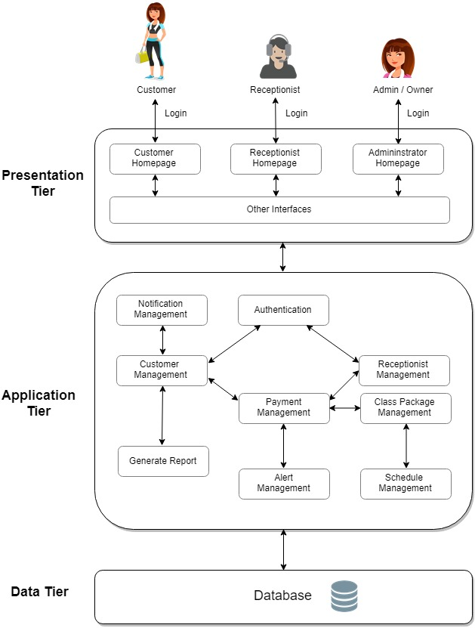

**4.2 Layers and their Responsibilities**

Three-tier architecture has three layers as described below.

**4.2.1 Presentation Tier**

The presentation-tier is basically the front-end of the system. Admin, receptionist and customer will interact with this layer. It is built using HTML,CSS,JavaScript,jQuery and Bootstrap and is accessible through a web browser..

Static web pages within our system are, About us page, Gallery page, Schedule page, Contact us page, etc. Since the users have different access rights, they will gain access to the system accordingly once they have logged into the system. The system users will be redirected as shown below after successfully logging into the system.

Admin/Owner - Administrator Homepage

Receptionist - Receptionist Homepage

Customer - Customer Homepage

Depending on the authorization level, users will gain access to other user interfaces such as Payment, Attendance, Report, etc.

**4.2.2 Application Tier**

The application-tier will interact with the presentation-tier. This layer contains the functional business logic of the system which are payment module, scheduling module, report generating module, notification module, alerting module, etc. This tier will be developed using PHP.

The **components and their responsibilities** are given below for the core functionalities identified in the application-tier.

|  |  |
| --- | --- |
| **Module** | **Main Functionalities** |
| Authentication | * Login to the system * Logout of the system * Authenticate users based on username and password |
| Customer Management | * Accept/Reject customer register requests * Register new customer * View customer details * Update customer details * Hold customer account * Delete customer |
| Receptionist Management | * Add receptionist * View receptionist details * Update receptionist details * Delete receptionist |
| Payment Management | * Handle online registration payments * Handle cash payments of registration * Handle online monthly payments * Handle monthly cash payments * Handle receptionist’s salary payment |
| Alert Management | * Send message alerts for delay in payments |
| Schedule Management | * Add new zumba session * View/Extend the client limit on each time slot * View the number of enrolled customers for each slot (weekly) * Delete zumba session * Change pre reserved time slot ( reschedule /delete ) |
| Class Package Management | * Select class package * Edit class package selection * Remove class package selection |
| Notification Management | * Send general notification * Send health tip * Send medical advice |
| Generate Report | * Generate report on attendance * Generate report on weights |

**4.2.3 Data Tier**

Application-tier will be interacting with the data-tier. This data-tier comprises of the database of our system and is used to store and retrieve data. MySQL is the DBMS used for this system.

**4.3 Component Interactions**

Shown below is a block diagram to describe the application-tier within our system. This depicts the **components** and **component interactions** that we have identified.

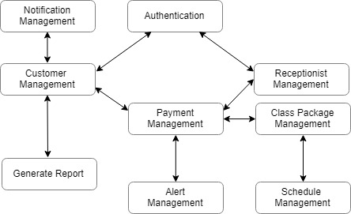

**5. SYSTEM DESIGN**

**5.1 Class Diagram**

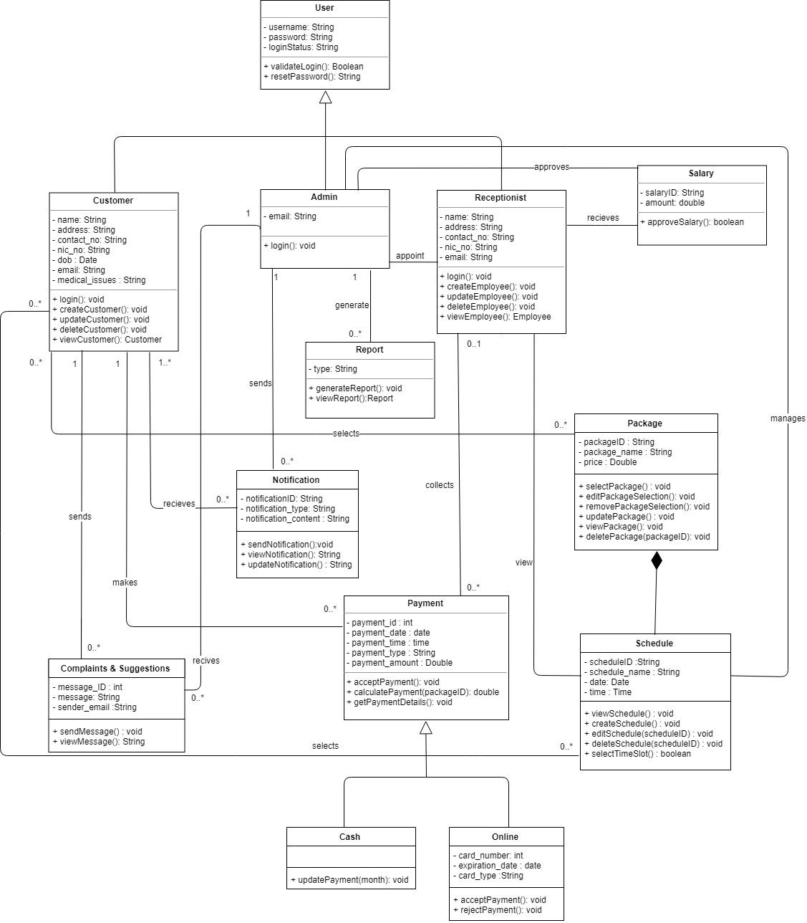

**5.2 Sequence Diagrams** 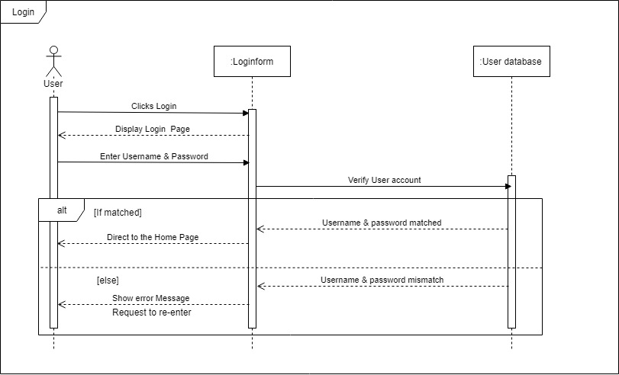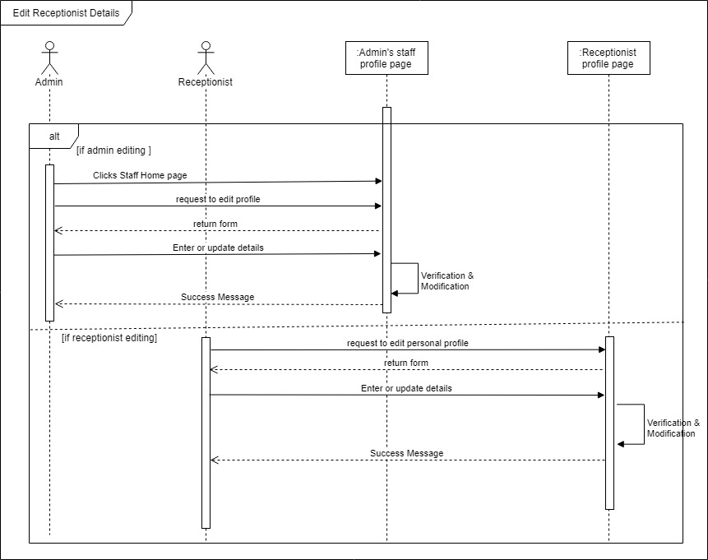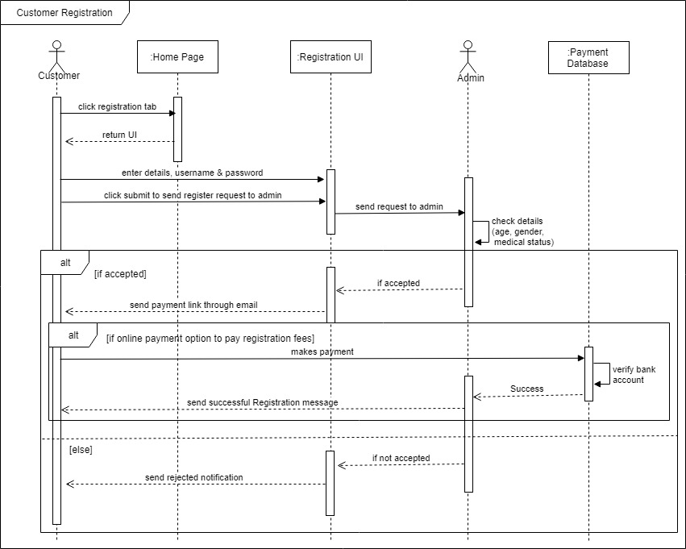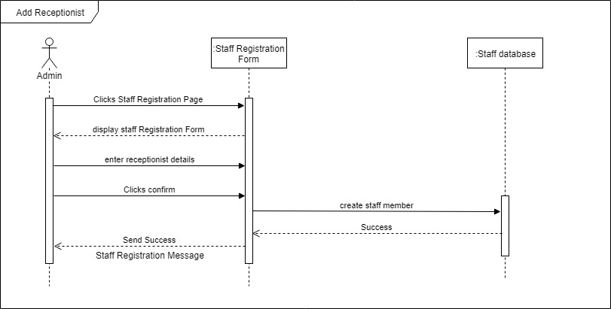

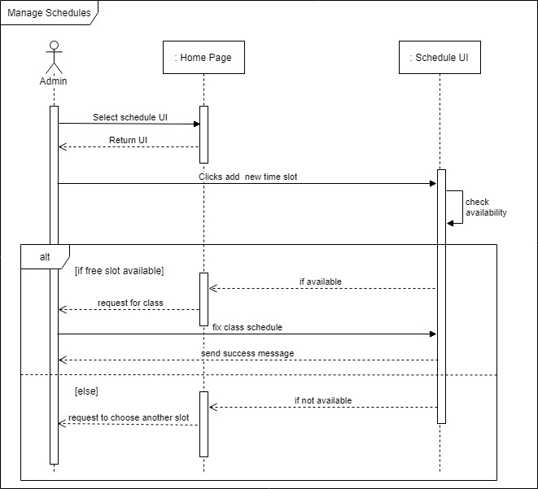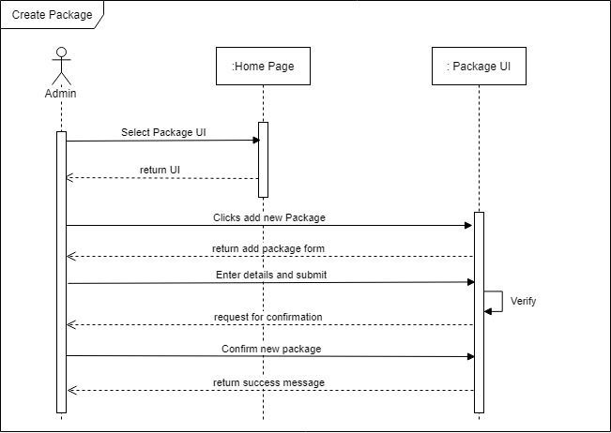

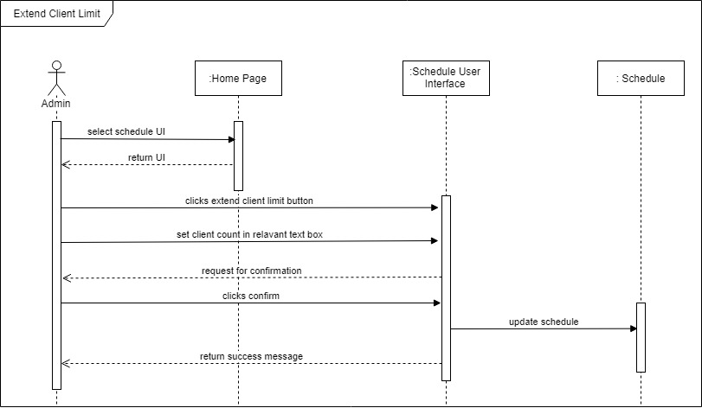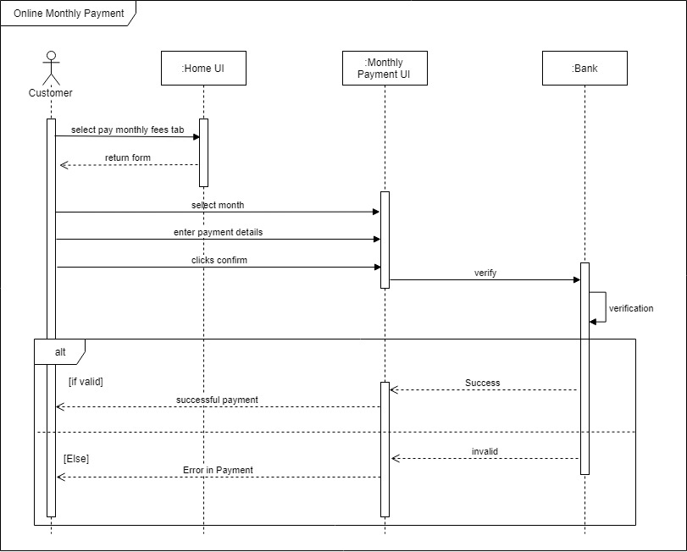

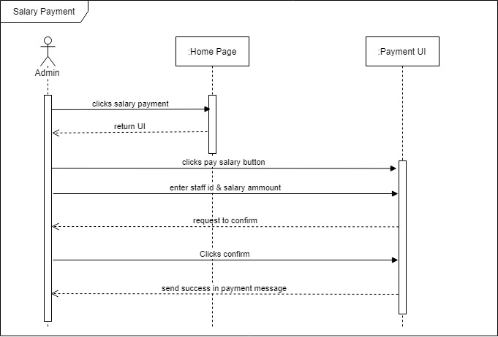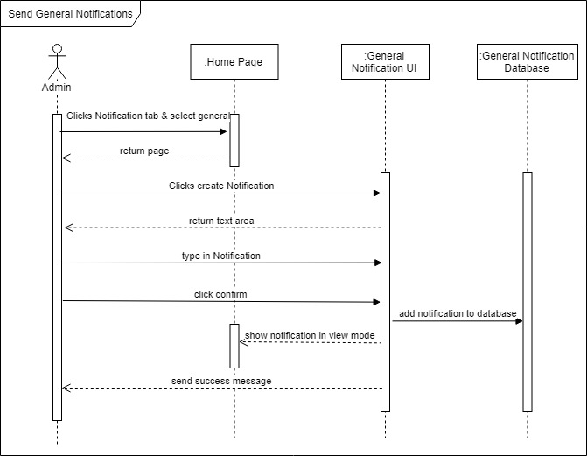

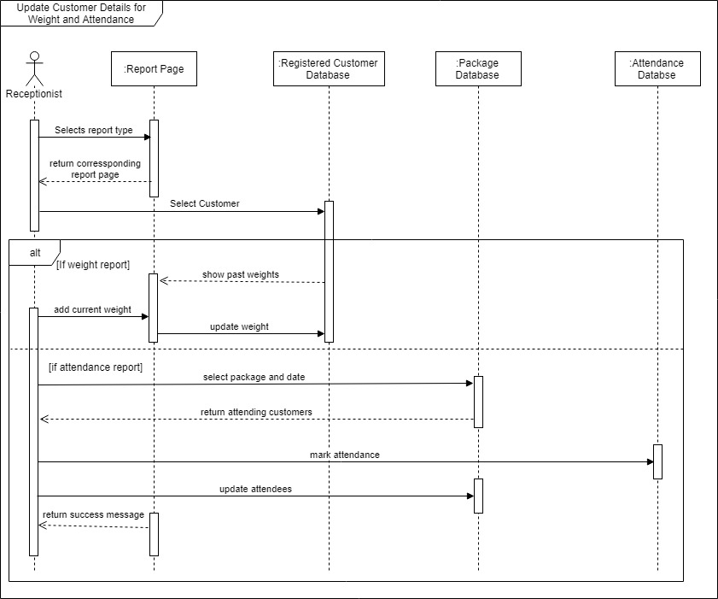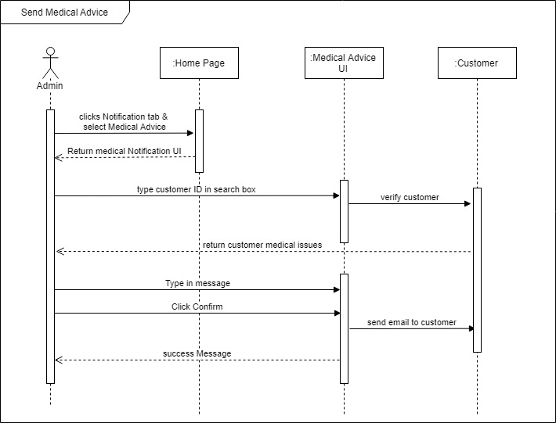

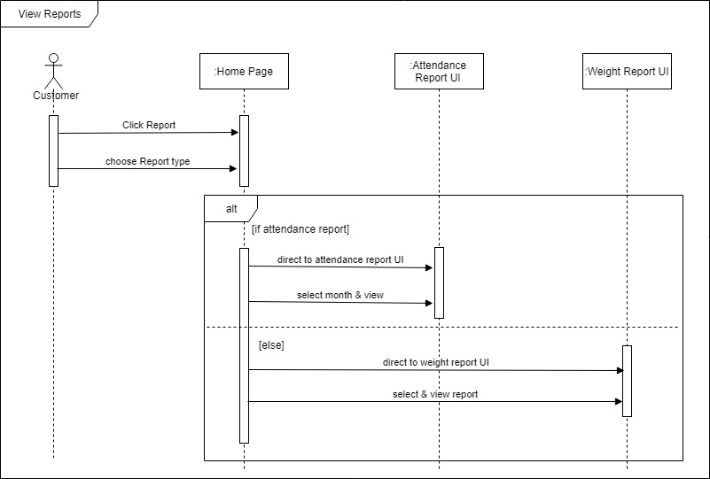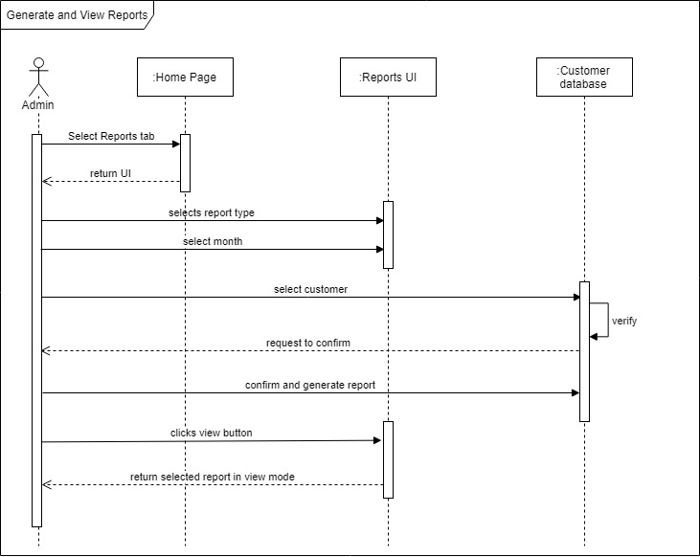

**5.3 Activity Diagrams**

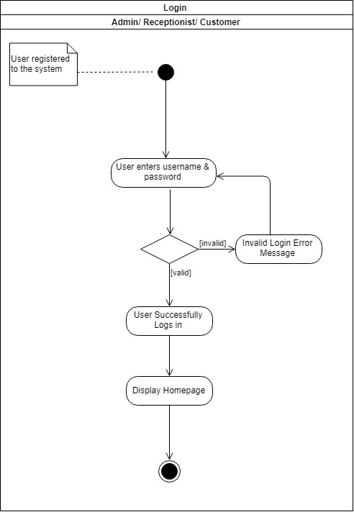

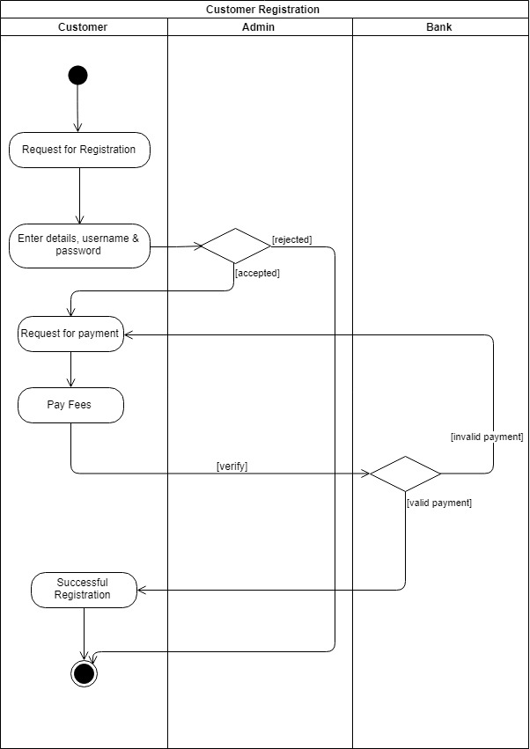

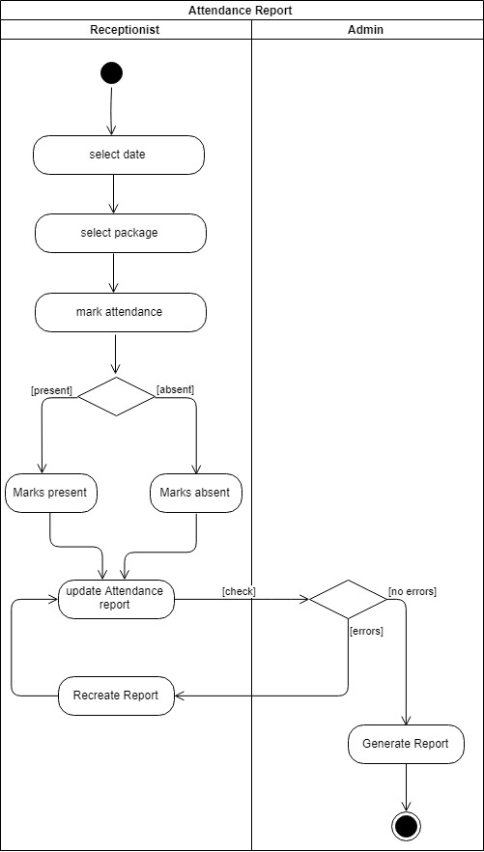

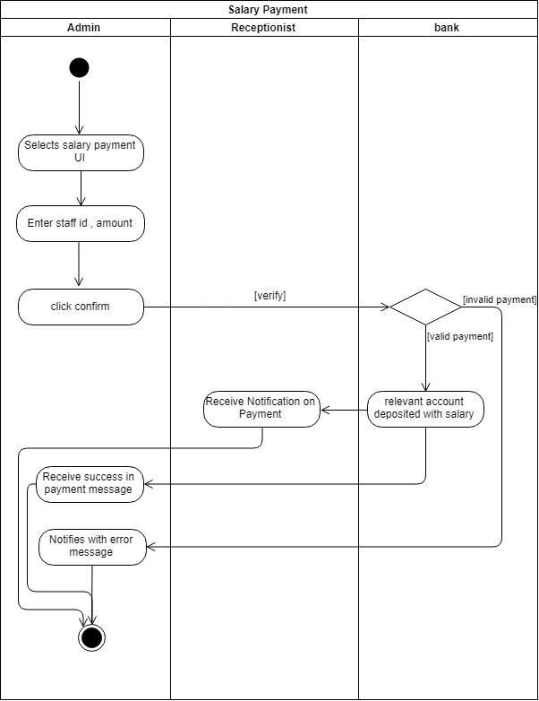

**5.4 Database Design**

**5.4.1 Entity Relationship Diagram (ERD)** 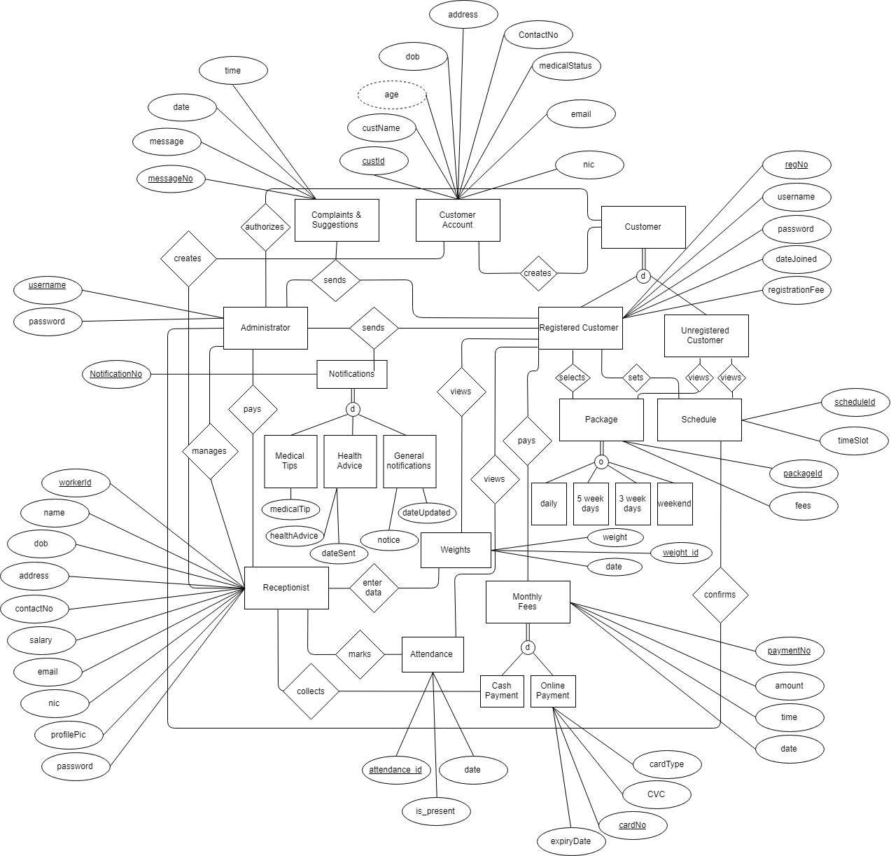

**Assumptions:**

The alerts are sent automatically by the system for delay in payments (monthly). This is a predefined message and need not be saved in the database

Reports are generated when requested, using the data which are already stored in the database, therefore there is no need to store the reports in the database.

**6. INTERFACES**

**6.1 User Interface Flow Diagrams**

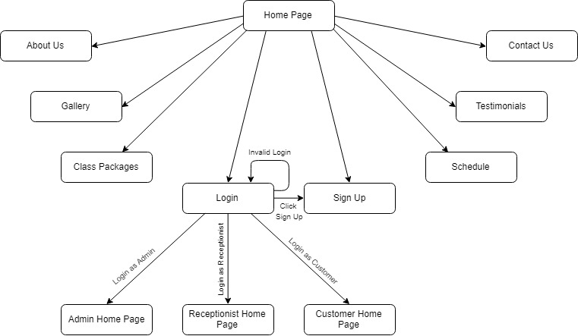

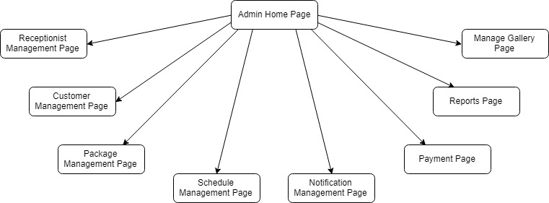

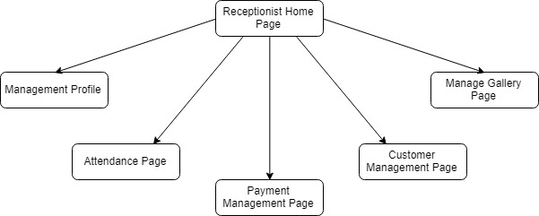

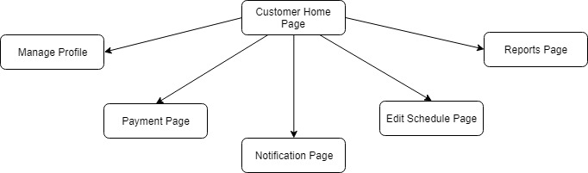

**6.2 User Interface Mockups**

Some of the User Interface Mockups are shown below